PROGRAM POLE (version 8a)

Version 23/JAN/2007
***********************************************************************
Developed by: Carlos Tomé
MST-8 MS G755
Los Alamos National Laboratory
Los Alamos NM 87545 USA
e-mail: tome@lanl.gov

Feel free to use this software. Please acknowledge the source.
***********************************************************************

1- GENERAL DESCRIPTION

POLE8 is a Fortran 77 code for making pole figures and inverse pole figures. User has to provide a Texture File, consisting of a discrete set of crystal orientations, defined by their associated Euler angles and volume fractions. In addition, an input file provides the poles to be plotted expressed in three index notation (for cubic/tetragonal/orthogonal/monoclinic/triclinic crystals) or four-index notation (for hexagonal/trigonal crystals).

Creates an output file POLE8.OUT containing the information about the pole figure for plotting with PLOTPF8.FOR.
Also creates a set of output ASCII files with (X,Y) coordinates for plotting with any other graphic software.
The strategy is to use POLE8 as a purely numerical code which generates (X,Y) data files for plotting with any graphic software available to the user (such as ORIGIN or GNUPLOT or EXCEL). In this way, the code becomes independent of the hardware and software, except for the requirement of having a Fortran compiler (I use Lahey Fortran 90) and a graphic library (I use PLOT88) or other graphic software (I use ORIGIN).
The executable version of POLE8 provided with this manual has to be run from a MS-DOS window. If instead you compile the source code then it depends on the compiler used.

2- CODE CAPABILITIES

POLE8 features the following options:
- Reads Bunge, Kocks or Roe conventions of Euler angles.
- Plots dots or intensity lines. When plotting intensity lines divides the Pole Figure or Inverse Pole Figure in cells using a grid, assigns weights to the cells of the grid, calculates intensities associated with the center of each cell, and interpolates intensities to derive level lines.
- Uses equal area or stereographic projection.
- When plotting lines uses a (phi,theta) or a (phi,cos(theta)) grid.
- Optional symmetrization of the original set of poles: centro-symmetry (inversion), X mirror plane, Y mirror plane, two (X & Y) mirror planes (orthotropic), axisymmetry.
- ‘Gaussian' spreading of the poles for smoother representation.
- Plots intensity lines at equal or geometric increments, or for arbitrary values.
- Plots pole figures for arbitrary crystal symmetry (cubic, hexag, trigo, tetra, ortho, monoc, tricl).
- Plots inverse pole figures for arbitrary crystal symmetry.
- Plots several poles for several textures simultaneously.

3- USER DEFINED PARAMETERS

User has to provide plotting parameters using one of the following options:
- Interactively through the screen using mostly default values (default=0).
- Interactively through the screen choosing every parameter (default=1).
- Reading the parameters from a profile (POLE8.PRO) which is created in each run, contains the parameters of the run, and can be edited by the user if desired (default=-1).

The following are the options for representing Pole Figures and Inverse Pole Figures.
Most parameters control plotting of intensity lines and do not apply when plotting dots.
Default is always the zero value of the parameter when appropriate.

- mgrid, ngrid: partition of [0< phi <2π] and [0< theta <π/2] intervals (default: mgrid=36, ngrid= 9, corresponding to 10 deg cells).
- spread: introduces a Gaussian spread around each pole. Smoothes the pole figure. spread represents the radious (in degrees) swept by the Gaussian (default: spread=2π / 2*mgrid).
- icros: plot crosses in PF where intensity is below the minimum (icros= 0) or not (icros=1).
- crysym: this parameter is read from single crystal file and gives information about the crystal symmetry: crysym=CUBIC, HEXAG, TRIGO, TETRA, ORTHO, MONOC, TRICL identifies cubic, hexagonal, trigonal, tetragonal, orthogonal, monoclinic, triclinic, respectively.
- idraw: plot all the intensity lines that correspond to the increment chosen (idraw=0) or eliminate some of them (idraw=1). An alternative to this approach is to manually enter the intensity levels to be plotted via POLE8.PRO.
- ifull: plot pole figure using a full circle (ifull=0) or plot only a reduced circular section depending on the symmetry enforced by isym (ifull=1).
- igrid: use equal partition of (phi,theta) (igrid=0) or (phi, cos(theta)) (igrid=1).
- iper1, iper2, iper3: the user is prompted to enter the position of the sample axes in the PF. Specifically: which axis goes at the right (iper1), which at the top (iper2) and which at the center of the PF (iper3). For example, it is usual to plot rolling textures with the TD at the right, the RD at the top, and the ND at the center of the pole figure. If the texture is referred to a set of axes where RD=1, TD=2, and ND=3 then one would enter iper1=2, iper2=1, iper3=3. It is allowed to enter negative axes, such as iper1=-2 or iper3=-3, for example.
- ipfig: controls whether plotting a Direct PF or an Inverse PF.
if ipfig=0 the poles read from POLE8.IN will be plot in a direct PF.
if ipfig=1 the vectors (100) or (010) or (001) read from POLE8.IN will be plot in an Inv. PF.
- iproj: use equal area projection (iproj=0) or stereographic projection (iproj=1).
- irepr: represent PF or IPF using intensity lines (irepr=0) or points (irepr=1).
- isepa: plot intensity levels using equal increments on a linear scale (isepa=1) or equal increments on a logarithmic scale (isepa=0).
- step: increment used to define the intensity line values.
Level(l)=2^(step*(l-2)) if isepa=0.
Level(l)=step*l if isepa=1.
- ishft: introduce a half-cell rotation in phi in order to make possible for maxima to coincide with the main axes (ishft=1) or not (ishft=0).
- ismth: smooth the central part of the PF. Used mostly for cosmetics, when the center exhibits a ‘spiky’ appearance.
ismth=0 → does not do any smoothing
ismth=1,2,3…10 → represent increasing levels of smoothing
- isym: enforces a specific symmetrization in the PF (both, points or intensity line representation).
isym=0 : do not symmetrize the PF
isym=1 : enforce a centro-symmetric pole figure
isym=2 : enforce a mirror plane perpendicular to the horizontal axis of the PF
isym=3 : enforce a mirror plane perpendicular to the vertical axis of the PF
isym=4 : enforce two mirror planes (orthotropic)
isym=-1 : enforce axial symmetry of the PF (may be used for deriving volume fractions)
- iwrite: label intensity lines with the value of the level (iwrite=1) or not (iwrite=0). Using this option will be graphic-software specific, and is not necessary if color/format coded intensity lines are plot.
- pfrot: a rotation angle in degrees. Default pfrot=0˚. Allows user to rotate the poles around the center of the PF. Used to ‘re-position’ experimental pole figures when the sample has not been properly positioned in the goniometer.

4- INPUT FILES

POLE8 requires three input files: POLE8.IN, a texture file and a crystal file. Optionally, POLE8.PRO may be used as the parameter input file (see description in OUTPUT files)

************************************************************************************

POLE8.IN
(Notice that this file contains information about several crystal symmetries. Only one symmetry is used at a time. The corresponding lines have to be moved ‘up-front’. See examples)
************************************************************************************
* number of texture files 'ntextfiles' to read below
3
* path & name of texture files (one per line)
c:\textures\mg_agnew\extr8378.tex
c:\textures\mg_agnew\1616.tex
c:\textures\mg_agnew\2679.tex
* path & name of file with symmetry & cell parameters of single crystal
datasx\mg.sx
* index 'ipfig': 0 for pole fig plot, 1 for inverse pole fig plot
0
* # of crystallographic poles (PF) or sample axes (IPF) to read below
3
* Miller indices of poles
0 0 0 1 ! 1 basal pole
1 0 -1 0 ! 3 prism 1st order poles
1 0 -1 1 ! 6 pyramidal 1st order poles

******** cut & paste above for different symmetries **************

* Miller indices of poles for cubics
1 1 0 ! 6 (110) poles
1 0 0 ! 3 (100) poles
2 1 1 ! 12 (112) poles

* indices of sample axis for (IPF)
1 0 0 ! x1 axis for IPF
0 1 0 ! x2 axis for IPF
0 0 1 ! x3 axis for IPF

* Miller indices of poles for monoclinic
1 1 1 ! 2 (111) poles
1 3 1 ! 2 (131) poles
-1 3 1 ! 2 (-131) poles
1 0 0 ! 1 (100) pole
0 1 0 ! 1 (010) pole
0 0 1 ! 1 (001) pole

* Miller indices of poles for hexag and trigonal
0 0 0 1 ! 1 basal pole
1 0 -1 0 ! 3 prism 1st order poles
2 -1 -1 0 ! 3 prism 2nd order poles
1 0 -1 1 ! 6 pyramidal 1st order poles
1 0 -1 2 ! 6 pyramidal 2nd order poles

* Miller indices of poles for orthorhombic
1 1 1 ! 4 (111) poles
1 0 0 ! 1 (100) pole
0 1 0 ! 1 (010) pole
0 0 1 ! 1 (001) pole
***************************************************************************
Line 1: reminder
Line 2: number of texture files to read below, for which PF or IPF are going to be plot. POLE8 allows to plot several poles (up to 8) for several textures (up to 8). Each the texture file may contain one or several textures, separated by appropriate heading.
Line 3: reminder.
Line 4: path and name of texture files. If more than one, use one line for each file listed.
Line 5: reminder
Line 6: parameter ‘ipfig’ indicating whether Direct or Inverse Pole Figures are plot.
Line 7: reminder
Line 8: number of different poles (npoles) to be read below and to be plot. When plotting IPF's this number indicates the number of IPF’s to be plot.
Line 9: reminder
Line 10+: Miller indices of poles to be plotted (3-index notation for cubic, ortho, monoc, tricl; 4-index notation for hexagonal and trigonal). These lines contain the coordinates (100) and/or (010) and/or (001) of the sample axes to be plotted when plotting IPF's.

******************************************************************************
TEXTURE FILE(s) (path and name declared in POLE8.IN)
******************************************************************************
TEXTURE AT STRAIN = 0.5000
1.555 1.000 0.630 <-- axes length of macro ellipsoid
90.00 90.00 0.00 <-- Euler angles of macro ellipsoid (deg)
B 500
-107.05 105.24 -41.51 0.0020000
-145.57 41.09 64.31 0.0020000
62.21 127.40 -116.27 0.0020000
-58.49 123.53 -52.69 0.0020000
-58.36 73.80 109.54 0.0020000
--- --- --- ---
***************************************************************************
Line 1: reminder
Line 2: reminder
Line 3: reminder
Line 4: angle convention (B or b: Bunge; R or r: Roe; K or k: Kocks) and number of orientations listed below. The latter indicates how many lines have to be read until end of texture.
Lines 5+: angles phi1, PHI, phi2 (Bunge) and volume fraction (weight) of the orientation

A similar block with the same structure may follow in the same file. POLE8 will read and store all textures until reaching the end of the file. It will then open and read from the next texture file in the list, if appropriate.

******************************************************************************
SINGLE CRYSTAL FILE (path and name declared in POLE8.IN)
******************************************************************************
POLE8 reads the symmetry of the single crystal (CRYSYM=cubic, hexag, orhto, tricl, etc) and the parameters of the unit cell; the length of the three vectors (a,b,c) and the angles that they form (α,β,γ). This data is used for calculating the symmetry operations and the normal vectors associated with the different poles.
The single crystal file has the format also used by other codes (VPSC & EPSC). A few examples are shown below. The first line is a reminder. The second lines gives CRYSYM.. The third line gives the lattice parameters.

___________________________________
Mg - AZ31B
HEXAGONAL crysym
1. 1. 1.61 90. 90. 120. cdim(i),cang(i)
___________________________________
*Material: fcc AUSTENITIC STEEL
cubic crysym
1.0 1.0 1.0 90. 90. 90. unit cell axes and angles
___________________________________
* orthrhombic Uranium
orthorhombic
1.0 2.056 1.736 90. 90. 90.
_________________________________
* monoclinic uranium
monoclinic
2.906 5.737 4.971 90. 90. 92.89
__________________________________
* olivine
trigonal
6.01 4.78 10.3 90. 90. 120.
__________________________________
5- OUTPUT FILES

When running POLE8 the user is prompted to enter a 5 character string (i.e. DUMMY) for labeling the output files. All output files start with these 5 characters.
All the output files used for plotting consist of two columns of (x,y) data. Different data groups (either another intensity line, or another pole figure, or another texture) are separated by a line containing two hyphens ( - - ) to indicate a break in the point-joining operation. Plotting files are:

DUMMY_CC.DAT: Contains coordinates for drawing the circle, half-circle, or quarter circle that encloses the PF or IPF. Plot by joining the points consecutively.

For line plots:
* DUMMY_XX.DAT: Coordinates of points where the intensity is lower than the minimum line to be drawn. Permits to plot dots or crosses in the areas of low intensity, and helps to read the PF.
* DUMMYnnn.DAT: Coordinates of points defining the intensity line of value 'nnn'. Join points sequentially. A ( - - ) line in the file separates different intensity lines having the same level.
* DUMMY_MX.DAT: a small file giving the x,y coordinates of the maximum intensity, and the intensity value. One line per pole and per texture.

For dot plots:
* DUMMY_Xn (with n=0,9): Coordinates of poles for plotting them as points or crosses (as opposed to intensity lines). The poles are distributed in ten bins, depending on the relative weight of the grain from which they originate. n=0 represents the minimum and n=9 the maximum. The user may want to plot them using symbols proportional to the value 'n'.

5-1 OUTPUT FILES WHICH ARE USEFUL BUT NOT NECESSARY

POLE8.OUT: it is meant to be read by another program (PLOTPF8 which links with the graphic library PLOT88. Unless you use PLOT88, neither POLE8.OUT nor PLOTPF8.FOR are going to be of much help, except for giving the user an idea of a possible plotting strategy.

POLE8.PRO: a file listing the parameters used in the last run. When running the code, the user is prompted to choose parameters (DEFAULT=1), run default parameters (DEFAULT=0), or read them from POLE8.PRO (DEFAULT=-1). POLE8.PRO is overwritten after each run. It comes handy when making several plots using the same parameters, or to save plotting profiles to be used for different cases, or to read arbitrary values for the intensity lines (as opposed to equally spaced). See description of parameters in Section 3. This file looks like:
__________________________________
ifull iproj irepr isym
0 0 0 -1
iper1 iper2 iper3
3 1 2
igrid mgrid ngrid
0 36 9
ishft ismth pfrot
0 7 0.00
icros idraw isepa iwrite spread step
0 0 0 0 5.00 0.50
nlevels
16
rlevel(l)
0.71 1.00 1.41 2.00 2.83 4.00 5.66 8.00
11.31 16.00 22.63 32.00 45.25 64.00 90.51 128.00
_________________________________

PROFILE.OUT: Intensity profiles as a function of angle θ (declination from pole to equator). Calculated only when axisymmetrizing the PF (ISYM=-1). Used, for estimating volume fraction of orientations within a range of angle θ.
Column 1: angle θ
Column 2: intensity I(θ)
Column 3: I(θ)*sin(θ)
Column 4: ∫ I(θ)*sin(θ) dθ volume fraction within a ring around the center of the PF.
Column 5: ∫ I(θ)*sin(θ) dθ accumulated volume fraction from the center of the PF up to a ring.
_________________________________
text_1.dat
poles 0 0 0 1
ang int vdens vfrac vfacc
0.81 0.13421 0.00190 0.00051 0.00051
10.80 0.13417 0.02514 0.00373 0.00424
19.72 0.04564 0.01540 0.00247 0.00671
28.97 0.05568 0.02696 0.00439 0.01110
38.30 0.12960 0.08033 0.01315 0.02425
47.68 0.06495 0.04803 0.00788 0.03214
57.07 0.11367 0.09541 0.01569 0.04782
66.47 0.79140 0.72561 0.11940 0.16722
75.88 2.05859 1.99641 0.32864 0.49586
85.29 3.07233 3.06197 0.50414 1.00000
_________________________________

GRIDINT.OUT: Intensity at each phi (longitude) ,theta (latitude) position in the PF. May be used if you want to numerically process the PF or plot intensity lines with a graphic software that can read this format. The reason why -185<phi<185 and 0<theta<95 is to allow the user to interpolate values within the correct interval -180<phi<180 and 0<theta<90
_________________________________
text_1.dat
poles 1 1 1
phi theta int
-185.000 0.810 0.000
-175.000 0.810 0.000
-165.000 0.810 0.000
-155.000 0.810 0.000
…………………..
135.000 94.706 0.569
145.000 94.706 0.401
155.000 94.706 0.366
165.000 94.706 1.029
175.000 94.706 2.900
185.000 94.706 2.170
_________________________________
6- EXAMPLES

Three examples follow which include the corresponding plots, the input file POLE8.IN, and the output file POLE8.PRO. The ASCII output files used for making the plots are included in the corresponding distribution folders.

6-1 Example 1: A simulated texture of rolled Cu (fcc). (111), (110), (100) poles plotted as points and intensity lines in the pole figure. In this example one texture and several poles are plot.

POLE8.IN → same for lines and dots
* number of texture files 'ntextfiles' to read below
1
* path & name of texture files (one per line)
example1\fcc_roll.tex
* path & name of file with symmetry & cell parameters of single crystal
datasx\fcc.sx
* index 'ipfig': 0 for pole fig plot, 1 for inverse pole fig plot
0
* number of crystallographic poles (PF) or sample axes (IPF) to read below
3
* Miller indices of poles
1 1 1
1 1 0
1 0 0

POLE8.PRO → for lines
ifull iproj irepr isym
0 0 0 0
iper1 iper2 iper3
2 1 3
igrid mgrid ngrid
0 36 9
ishft ismth pfrot
0 0 0.00
icros idraw isepa iwrite spread step
0 0 0 0 5.00 0.50
nlevels
16
rlevel(l)
0.71 1.00 1.41 2.00 2.83 4.00 5.66 8.00
11.31 16.00 22.63 32.00 45.25 64.00 90.51 128.00

POLE8.PRO → for dots
ifull iproj irepr isym
0 0 1 0
iper1 iper2 iper3
2 1 3
igrid mgrid ngrid
0 36 9
ishft ismth pfrot
0 0 0.00
icros idraw isepa iwrite spread step
0 0 0 0 5.00 0.00
nlevels
0
rlevel(l)
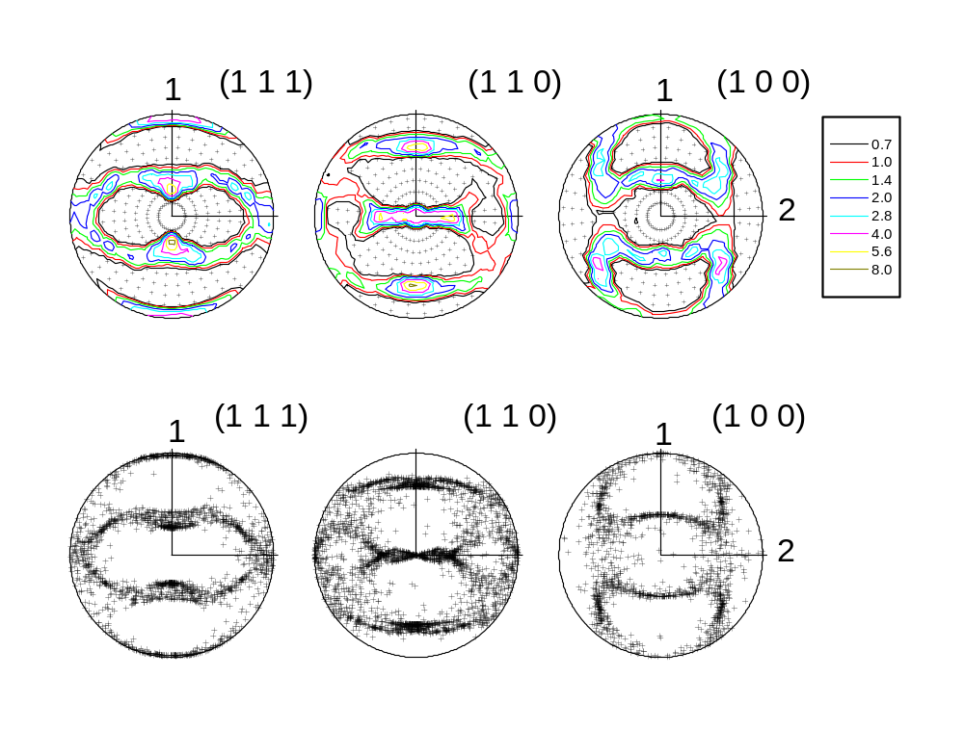

6-2 Example 2: Simulated textures of Cu (fcc) deformed by axial compression and tension.
Axis (001) is plot in Inverse Pole Figures, using lines and points. In this example two textures and one pole are plot.

POLE8.IN → same for lines and dots
* number of texture files 'ntextfiles' to read below
2
* path & name of texture files (one per line)
example2\fcc_comp.tex
example2\fcc_tens.tex
* path & name of file with symmetry & cell parameters of single crystal
datasx\fcc.sx
* index 'ipfig': 0 for pole fig plot, 1 for inverse pole fig plot
1
* number of crystallographic poles (PF) or sample axes (IPF) to read below
1
* Miller indices of poles
0 0 1

POLE8.PRO → for lines
ifull iproj irepr isym
0 0 0 0
iper1 iper2 iper3
1 2 3
igrid mgrid ngrid
0 72 18
ishft ismth pfrot
0 0 0.00
icros idraw isepa iwrite spread step
0 0 0 0 2.50 0.50
nlevels
8
rlevel(l)
1.00 2.00 4.00 8.00 16.00 32.00 64.00 128.00

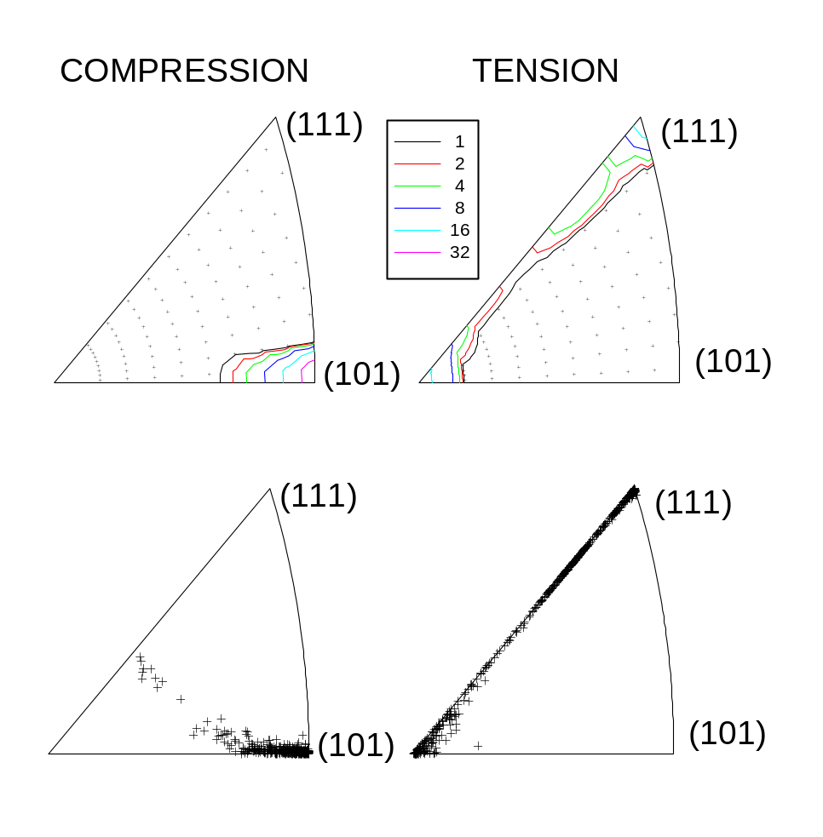

6-3 Example 3: Experimental textures for clock-rolled Zr (hcp) and the same Zr after 27% In-Plane Compression. Basal (0002), pyramidal (10-11) and prism (10-10) poles are plot for each texture in one single run of POLE8.

POLE8.IN
* number of texture files 'ntextfiles' to read below
2
* path & name of texture files (one per line)
example3\5678.tex
example3\7185.tex
* path & name of file with symmetry & cell parameters of single crystal
datasx\zr.sx
* index 'ipfig': 0 for pole fig plot, 1 for inverse pole fig plot
0
* number of crystallographic poles (PF) or sample axes (IPF) to read below
3
* Miller indices of poles for hexag and trigonal
0 0 0 1 ! 1 basal pole
1 0 -1 1 ! 6 pyramidal 1st order poles
1 0 -1 0 ! 3 prism 1st order poles

POLE8.PRO
ifull iproj irepr isym
0 0 0 0
iper1 iper2 iper3
1 2 3
igrid mgrid ngrid
0 36 9
ishft ismth pfrot
0 0 0.00
icros idraw isepa iwrite spread step
0 0 0 0 5.00 0.50
nlevels
16
rlevel(l)
0.71 1.00 1.41 2.00 2.83 4.00 5.66 8.00
11.31 16.00 22.63 32.00 45.25 64.00 90.51 128.00
